**Connect and Reflect with Bluetooth Mirrors**

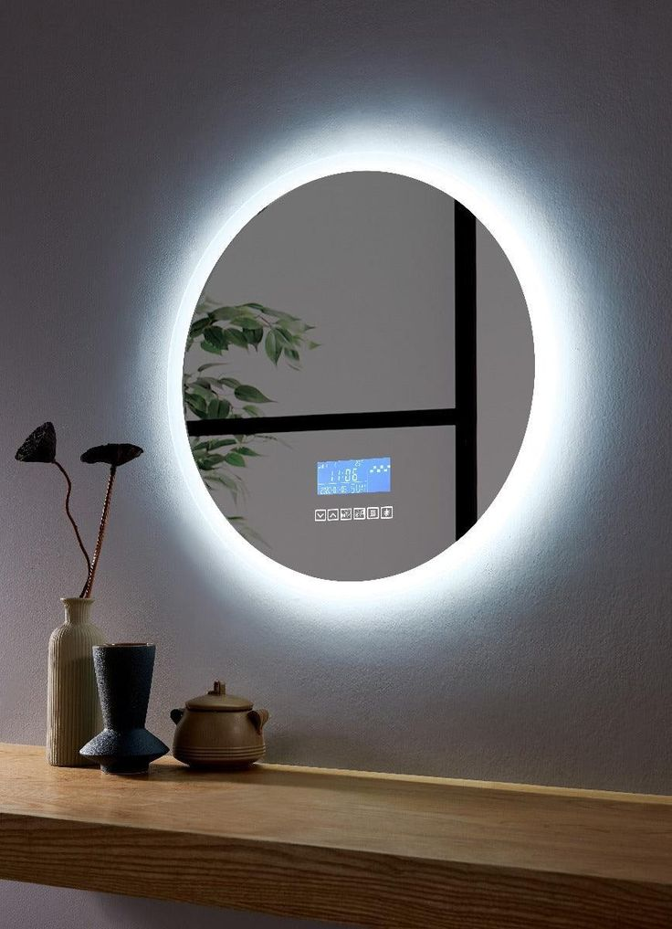

Bluetooth Mirrors combine modern design with advanced technology, offering not just a reflection, but a connected experience. With built-in Bluetooth speakers, these mirrors let you enjoy your favorite music, podcasts, or take hands-free calls while getting ready.

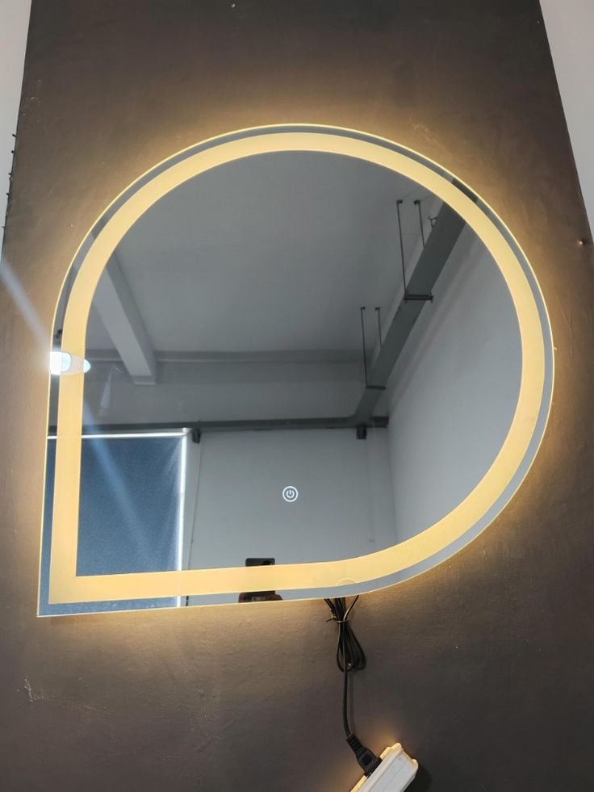

Perfect for bathrooms, bedrooms, or living areas, Bluetooth mirrors are designed to enhance your daily routine. The seamless connection to your smartphone or other devices ensures you stay entertained or informed without the need for extra gadgets cluttering your space.

Whether it’s for relaxing tunes while you unwind, or energetic beats to start your day, Bluetooth mirrors bring functionality and style to your home with convenience at your fingertips.

Elevate your space with a Bluetooth mirror — where technology and reflection meet in harmony.